**Lab-01**

1. Determine the perimeter of an object by using 4 connected neighborhoods and 8 connected neighborhoods.



1. Create a binary image using a threshold.

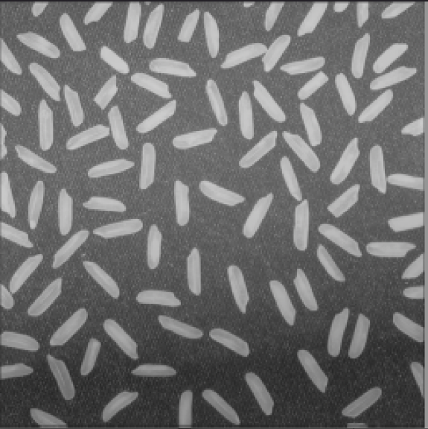

1. Determine the number of objects in the binary image generated in Question 2 using the concept of connectivity.
2. Find the Euclidean distance between two points of the image.

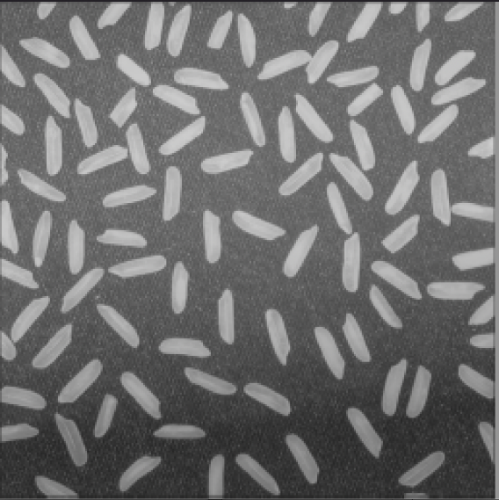

1. Apply the following operations using img1 and img2:
2. Addition
3. Subtraction
4. Multiplication
5. Division
6. Apply the following operations using img1 and img2:
7. AND
8. OR
9. NOT

7. Adjust the contrast of the following image.

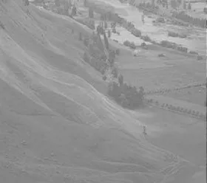

8. Brighten the following image



9. Quantize the Grayscale image by 8 levels.

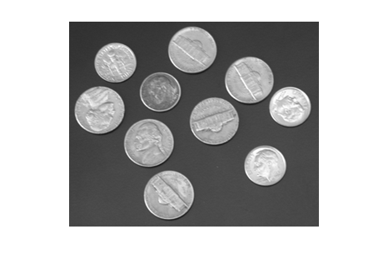

1. Find the digital negative of the image.

